Mohamed Waiel Shikfa
15112 and 76100

Term project proposal
Salem’s Adventure

- Project description: Salem’s Adventure: An animated interactive story, of a young Qatari genius who is going to travel through time to prevent the British from colonising Qatar in order to make Arabic the more spread language of communication. (For more see story flowchart)
- Competitive analysis: The project will be similar to the legend Zelda breath of the wild or super Mario odyssey. They are games I played and really got to enjoy. It will be similar in the sense that my project is going to be a story game, with dialogue boxes as the main mean of communication, but it won’t have anywhere near the same level of game and story development or player freedom, like the action of the player are going to be very limited and he is mostly going to follow the story through textual and graphical hints.
- Structural Plan: I am going to have a term project directory containing a main python file as well as multiple other smaller scene files. For data storage and loading I am going to use json files with python’s built-in json library. I am mainly going to have a json for each python file and after MVP I will try adding support to saving and loading game states by creating and using new json file.
- Algorithmic Plan: Because of the length complexity of the project, the main plan is a good use of OOP, data structures, code splitting and filesystem management.
- Timeline Plan: I plan to have scene 1 mostly ready for TP1. Then for TP2 and MVP I am planning to have at least 50% of the scenes done (although I hope I will be more like at 80%). Finally for the final project I will have all the scenes finalised with retouched graphics sound design and game state saving.
- Version Control Plan: git and private GitHub
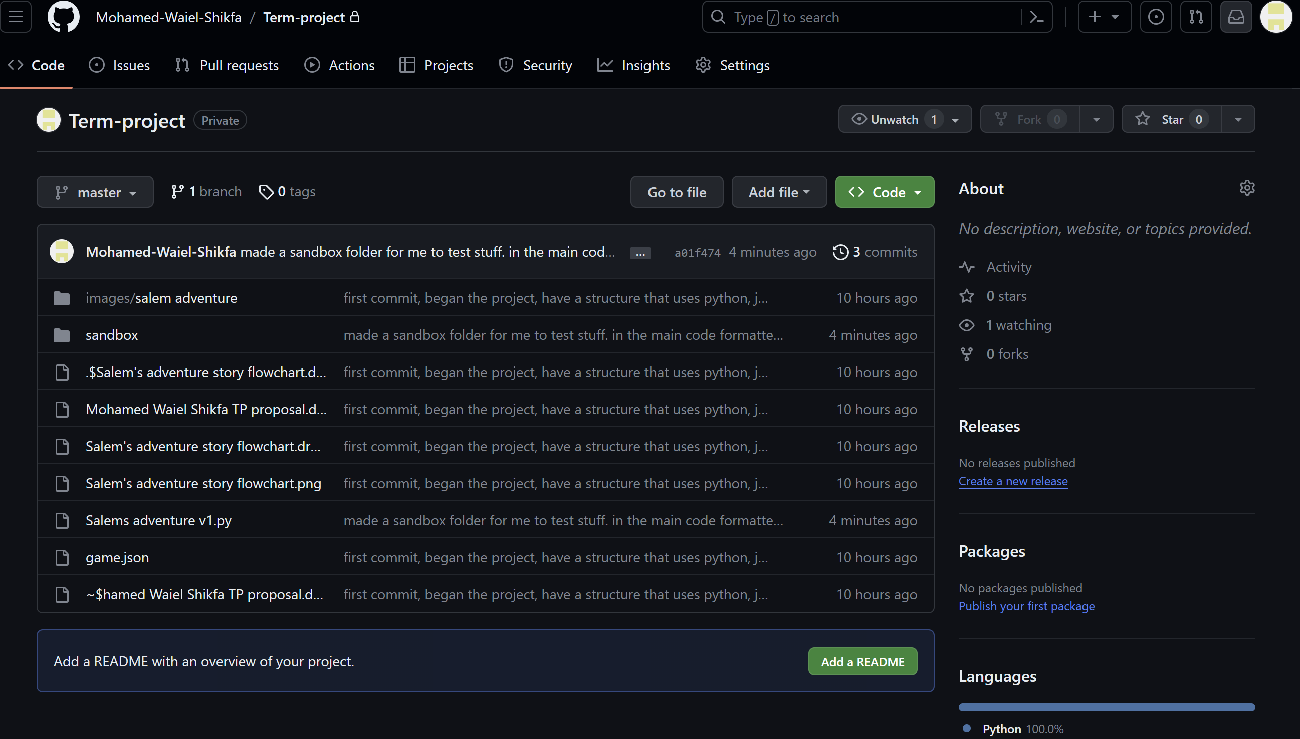
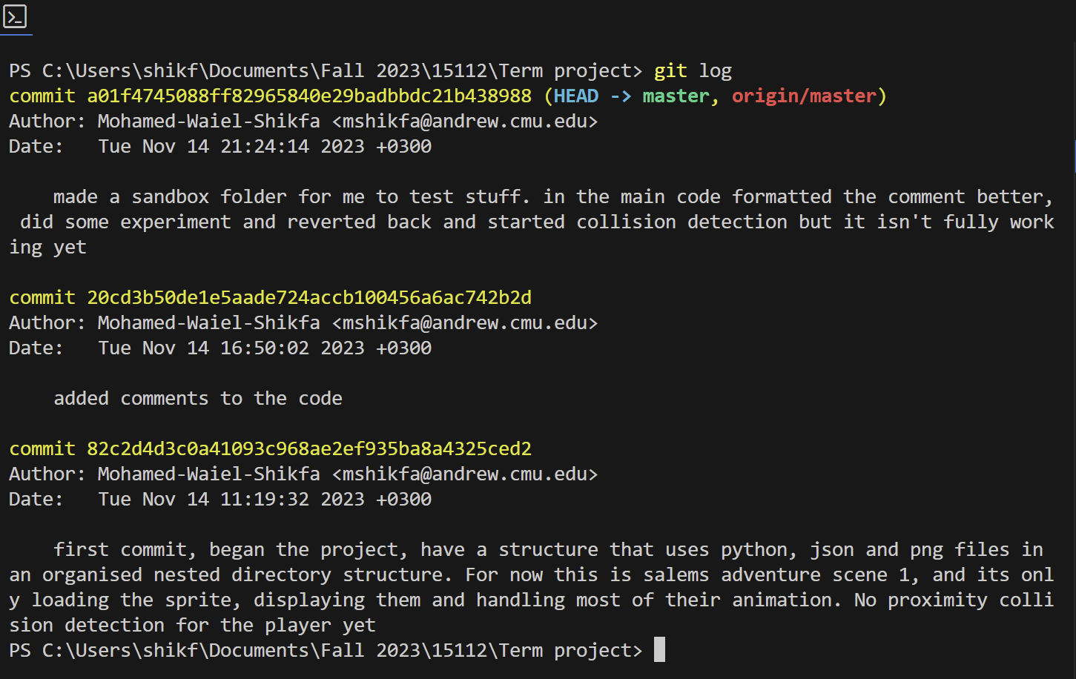
- Module List: If you are not planning to use any additional modules, that’s okay, just say so.

